Karnataka Valuation & E-Registration (KAVERI - 2.0)
Government of Karnataka

Functional Requirement Specifications

For KAVERI 2.0
Department of Stamps & Registration
Government of Karnataka

GIS-Based Market Valuation of Property
In Document Registration

Prepared by
Centre for Smart Governance (CSG)
2nd Floor, TTMC Yeshwanthapura, BMTC Bus station
Bangalore – 560022

Contents
1 Introduction 4
2 Document scope 4
3 Description of the functional requirement 5
3.1 AS-IS Process 5
3.1.1 Workflow - application submission 5
3.2 TO-BE Process 6
3.2.1 Market Valuation Determination 6
3.2.2 Revised Workflow - application submission 7
3.2.3 Interaction diagram 9
3.2.4 Workflow 11
3.2.5 Actors and their roles 12
3.2.6 Process Description 13
4 Valuation 14
4.1 Base rate determination 14
4.2 Annexure rules appreciation 17
5 Output documents 17
6 Scenarios to be considered 17
7 Validations 17
8 Assumptions 18
9 Limitations 18
10 Annexures 19
10.1 Annexure – 1: List of modules of Kaveri 2.0 19
10.2 Annexure- 2: Requirements as shared by the department 20
10.3 Annexure – 3: Agrilandtypes masters 21
10.4 Changes suggested during the demo 23
10.5 Annexure 5: Annexure Rules for Market valuation of Agricultural Properties 24
10.6 Annexure 6: Annexure Rules for Market valuation of Non -Agricultural properties 27

Acronyms
CSG | Centre for Smart Governance
KSRSAC | Karnataka State Remote Sensing Applications Centre

Revision History
Date | Version | Prepared by | Reviewed by | Description
06-11-2024 | 1.0 | Rajesh Hanbal  Principal Consultant | Yashodhara, DIGR (Valuation), DSR | First Version
14-11-2024 | 1.1 | Rajesh Hanbal  Principal Consultant | Sandeep Patil (PM New Initiatives) | As per the discussion held on 11-11-2024, the road name will be identified and provided by KSRSAC (section 3.1.2).
15-11-2024 | 1.2 | Rajesh Hanbal  Principal Consultant | Sandeep Patil (PM New Initiatives) | To clarify the integration protocol, the road name has been replaced with the road code (section 3.2.2).  Introduced the limitations of the market valuation process.
15-02-2025 | 1.3 | Rajesh Hanbal  Principal Consultant | Yet to be approved | - Change from manual road-based market valuation to a base rate approach.  - Changes in the application flow for piloted and non-piloted talukas.
17-02-2025 | 1.4 | Rajesh Hanbal  Principal Consultant | Yet to be approved | - Addition of revised guideline values.  - Addressing the agricultural land with an extent of less than 5 Guntas
06-04-2025 | 1.5 | Pavan Deshapande  Business Analyst | Submitted for approval | - Incorporated the changes suggested by the IGR team during the demonstration and the alienated land scenario.
22-04-2025 | 1.6 | Pavan Deshapande  Business Analyst | Submitted for approval | - Incorporated the changes as per the updated CVC guidelines.
28-04-2025 | 1.7 | Pavan Deshapande  Business Analyst | Submitted for approval | Updated the revised valuation rules in the FRS

Introduction
The Department of Stamps and Registration (henceforth referred to as “department”) is the custodian of registered public records such as Registration of Marriages and Firms, Documents about transactions namely sale, transfer or gift of immovable properties, Mortgage, Power of Attorneys, wills and many more. Maintenance and preservation of these critical public records is the prime responsibility of the department. The records or the information associated with registered records are to be made available to the public when requested through defined procedures. The department is also responsible for collecting stamp duty on behalf of the Government for specified transactions. The services are provided through 258 Sub-Registrar Offices (SROs), under the supervision of 35 District Registrar Offices, spread across the state.
The department has computerized the delivery of these services through the development of Kaveri software. KAVERI Online service is a web-based application of the department that provides an interface to the Applicants required for documents, marriage, and firm registration. It enables Applicants to know the details of stamp duty, property guidelines value, data entry for document registration and marriage registration, etc. The list of modules of Kaveri 2.0 is available in Annexure 1.

Document scope
This document is a Functional Requirement Specification (FRS) describing the functional features of the GIS-based market valuation along with associated changes to the document registration flow during application submission. The document is prepared by the Centre for Smart Governance (CSG) and has been submitted for department approval. The intended audience of the document is the departmental approving authority and the development team. The document was prepared based on consultation with the Department of Stamps and Registrations and KSRSAC on 5th November 2024, along with the note shared by the department (Annexure-1). Based on the subsequent discussions, the FRS has been revised to incorporate the fundamental change in valuation policy from manual road-based approach to an automated base rate approach. Further, while the development of the feature was still in progress, a demo was provided to the department on 19th March 25 at the meeting chaired by IGR, the feedback provided has been incorporated in the revised FRS.

The document describes the high-level integration protocol between the Kaveri development team and the KSRSAC team and the details of other related changes involved in the Kaveri software. However, its scope excludes the algorithms to be adopted by the KSRSAC team. Further, since it is piloted for agricultural properties, the determination of market valuation for non-agricultural properties remains unchanged.

Description of the functional requirement
Currently, stamp duty calculations are based on the “proper market value” of a property as determined by the Central Valuation Committee (CVC). However, rate fixing is prone to significant discretion and might potentially lead to a loss of revenue to the state exchequer. The feature seeks to reduce users' discretion and maximise revenue realisation by automating market value determination to the extent feasible. Further, the feature must visualise the property details on a map to make it intuitive for the users.

Thus, there are two key changes to the workflow
- Market valuation determination.
- Revision of workflow in application submission.

AS-IS Process

Workflow - application submission
Article Selection | Property Search | Property Schedule | Executant details | Party Allocation | Market Valuation | Fee Calculation | SRO selection and submission
 | Validations (PTCL/GR/GL)
 | Owner Selection
 | Extent Selection

As per the existing workflow, the application submission involves the following sequence of activities
- Article selection: Selection of article and sub-article.
- Property selection: Selection of property based on Bhoomi district, taluk, hobli, village, survey number/surnoc/hissa and Kaveri road_name
- Schedule Description: Addition of schedule description
- Party Information: Addition of party information including executant, claimant, address and their proof of identity.
- Market valuation: Determination of market valuation based on user selection of agrilandtype options and the annexure rules along with the road_name mentioned in step 2.
- Fee calculation: Calculation of stamp duty, registration fee and other fee as applicable.

Figure 5: As-Is workflow for application submission

TO-BE Process

Market Valuation Determination
The revised GIS-based property valuation system seeks to determine the property value automatically based on the extraction of features (Figure 4). It involves the following steps:
- User selection of property based on two options
  - Keying in the details like Bhoomi district, taluk, hobli, Index village and Survey number details.
  - Dropping a pin on the map.
- Kaveri to share the property information with KSRSAC.
- KSRSAC to extract features from various available sources.
- KSRSAC to combine the extracted features and identify the annexure rule codes.
- KSRSAC to share the annexure rule codes.
- Kaveri to determine the market valuation based on
  - Base rate.
  - Annexure rules provided by KSRSAC.
- Typical application flow continues hereon.
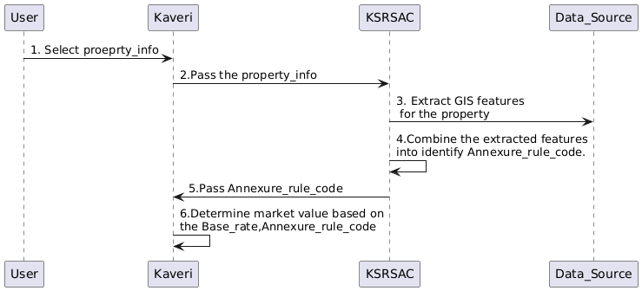

Figure 4: High-level proposed flow

The features such as source of irrigation, proximity to roads and crop produce are extracted from various GIS sources, including crop survey details and command area development authority (CADA) maps as provided in Annexure 5.

Revised Workflow - application submission
Alongside the changes to the logic of market value determination, changes are also to be made to the existing application submission workflow. These changes include
- Ability to select to property at the drop of a pin.
- Displaying market valuation along with property search.
- Visualising market valuation on an embedded map.
Article Selection | Property Search | Executant details | Party Allocation | Fee Calculation | SRO selection and submission
Article Selection | Validations (PTCL/GR/GL)
Article Selection | GIS-based visualisation
Article Selection | Owner Selection
Article Selection | Extent Selection
Article Selection | Market Valuation
Article Selection | Property Schedule

Figure 6: To-Be workflow for application submission

Interaction diagram
Figures 7 and 8 gives the high-level process flow of market valuation, both for piloted and non-piloted talukas
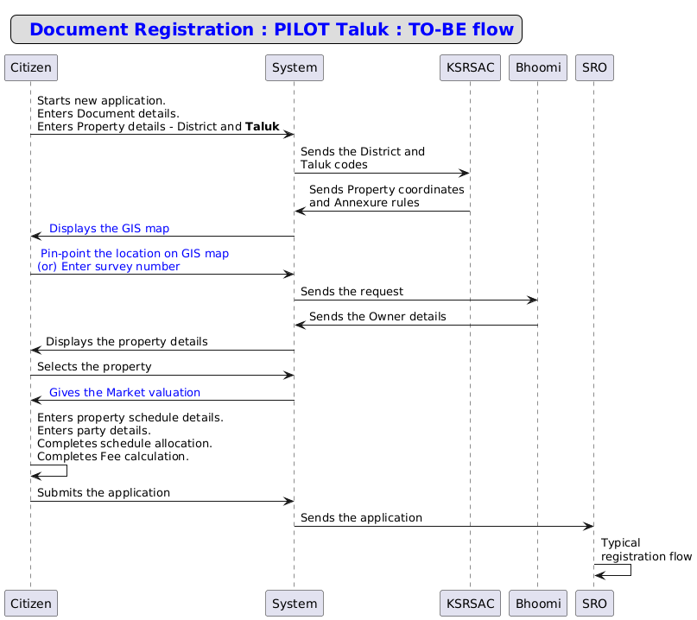
Figure 7: Interaction diagram for GIS-based market valuation for piloted talukas.
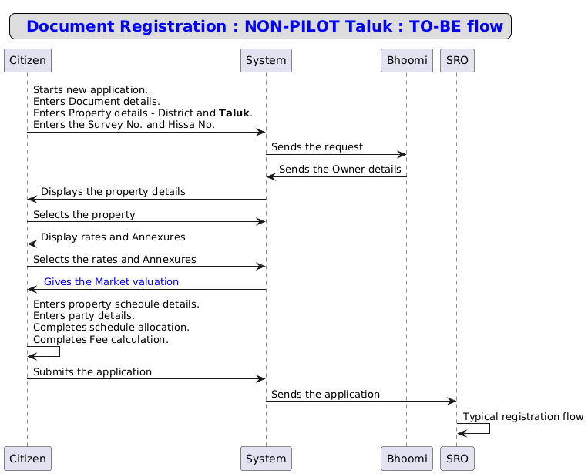

Figure 8: Interaction diagram of Market valuation for non-piloted talukas (agri and non-agri)

Workflow
Figure 9: Activity diagram of revised market valuation including piloted and non-piloted talukas.

Actors and their roles
Actor/Interface | Role/Responsibilities
Applicant | - Keys the relevant document details  - Pin-point the location of the property  - Selects extent type  [or]  - Keys the property details – survey no, hissa no.  - Selects extent type and annexures  - Continues with the application process
KSRSAC | - Populates the map and sends to the Kaveri system  - Sends relevant details along with annexure rule codes to the Kaveri system
System | - Displays GIS map for piloted taluks  - Stores the annexure rule codes  - Fetches party owner details from the Bhoomi system  - Displays the error message, if any restricted properties  - Displays rates and annexures  - Calculates market valuation based on user input and KSRSAC response
SRO | - Allocates to FDA/SDA or verification  - Verifies the application  - Calculates the market valuation and stamp duty fee. Overrides certain annexure rules input by applicant or provided by KSRSAC.  - Add remarks and send back to the applicant for correction, if required  - Send back to the applicant for payment
Bhoomi | - Sends back the property owner details to the Kaveri system
Process Triggers | - Selection of Taluk - piloted/ Non-piloted
Data/Information Required | - Annexure rule codes
Output documents generated | - Application summary

Process Description
Citizen Login
- Log in and select the new application.
- Select the article and sub-article.
- Property selection: Key in the following details to fetch the details.
  - District (Dropdown).
  - Taluka (Dropdown):
    - If the selected taluk is a pilot taluk, then the system will display the maps.
      - Drop a pin on a property to select it, or Select Hobli, Index village and Survey Number from drop respective dropdowns.
      - Select the owner details and choose the extent.
      - The system will display the base rate based on the input provided by KASRAC, such as the Village code and Annexure rule codes.

(OR)

    - If the selected taluka is not a pilot taluka, then the citizen will key in the following details.
      - Select Hobli, Index Village and select the road code from the respective dropdowns.
      - Key in the survey number and select the surnoc/hissa number.
      - Choose the owner details and extent for the transaction from the Bhoomi results.
      - Select the Rates and annexure rules to evaluate the property.
- Market Valuation:
For piloted taluks, the applicant clicks the Continue button to confirm the selected property. The system then displays the valuation, including the base rate, soil type, road type, crop type, and tree type. The applicant must enter the tree count, after which the system calculates and displays the total market valuation based on inputs from KSRSAC (village code, annexure rule codes) and the applicant (tree count).
For non-piloted taluks, the applicant selects the Rate and Annexure rules from the provided list. The system then displays the market valuation on the same page.
- Click on Continue to proceed further.
- Click on add a property to add another property, else click next to proceed further.
- Property schedule should be auto-generated, and the user should not be allowed to edit boundary details and schedule description, and click on continue.
- Party Information: Addition of party information including the executant, claimant, address and their proof of identity.
- Allocate the schedules and proceed to Fee calculation: Calculate stamp duty, registration fee, and other fees as applicable.
- Verify the summary, choose the SRO and submit the application.
The detailed wireframes are available here.

SR Login
The SR open the application for verification. During verification, SR can change the valuation by changing the following parameters.
- Land type: SR can change the land type existing to the land type having a higher base value.
- Tree Count: SR can increase the count of trees.
- Construction Details: SR can increase the construction details or add the construction details if the details are not provided by KSRSAC.

Valuation
The market valuation process for GIS-based Market valuation is redesigned using a base rate approach. The annexure rules will apply on top of the base rate.

Base rate determination
The base rate for each village is fixed by the Central Valuation Committee (CVC). The base rate for agricultural and non-agricultural land types will be distinct. The following three scenarios exist for the calculation of the base rate:
- Agricultural land type
- Less than 5 gunta
- Converted but underdeveloped 0
Sl No | Scenario | Sub-Scenario 1 | Sub-Scenario 2 | Sub-Scenario 3 | Rates
1 | Agricultural land |  |  |  | Base rate as given by CVC
2 | Agricultural land (Less than 10 gunta) | Less than 5 gunta |  |  | Maximum of (vacant site rate, agri rate converted to sq metre).
2 | Agricultural land (Less than 10 gunta) | 5-10 gunta |  |  | Maximum of (70% of vacant site rate, agri rate converted to sq metre).
3 | Converted underdeveloped land | Urban | < 5 gunta |  | Maximum of (vacant site rate, agri rate converted to sq metre).
3 | Converted underdeveloped land | Urban | 5 - 10 gunta |  | Maximum of (70% of vacant site rate, agri rate converted to sq metre).
3 | Converted underdeveloped land | Urban | 10-20 gunta |  | Maximum of (60% of vacant site rate, agri rate converted to sq metre).
3 | Converted underdeveloped land | Urban | 20-40 gunta |  | Maximum of (55% of vacant site rate, agri rate converted to sq metre).
3 | Converted underdeveloped land | Urban | More than 1 Acre | Industrial | 55% more than the Agri base rate
 |  |  |  | Residential | 65% more than the Agri base rate
 |  |  |  | Commercial/Non-residential | 80% more than the Agri base rate
 |  |  |  | Solar and Windmill | 75% more than the Agri base rate
 |  |  |  | SEZ | 100% more than the Agri base rate
 |  |  |  | Warehouse, Educational, Hospital and others | 75% more than the Agri base rate
3 | Converted underdeveloped land | Rural | < 5 gunta |  | Maximum of (vacant site rate, agri rate converted to sq metre).
3 | Converted underdeveloped land | Rural | 5 - 10 gunta |  | Maximum of (70% of vacant site rate, agri rate converted to sq metre).
3 | Converted underdeveloped land | Rural | More than 10 gunta | Industrial | 55% more than the Agri base rate
 |  |  |  | Residential | 65% more than the Agri base rate
 |  |  |  | Commercial/Non-residential | 80% more than the Agri base rate
 |  |  |  | Solar and Windmill | 75% more than the Agri base rate
 |  |  |  | SEZ | 100% more than the Agri base rate
 |  |  |  | Warehouse, Educational, Hospital and others | 75% more than the Agri base rate
Algorithm for determining base rate as depicted below:
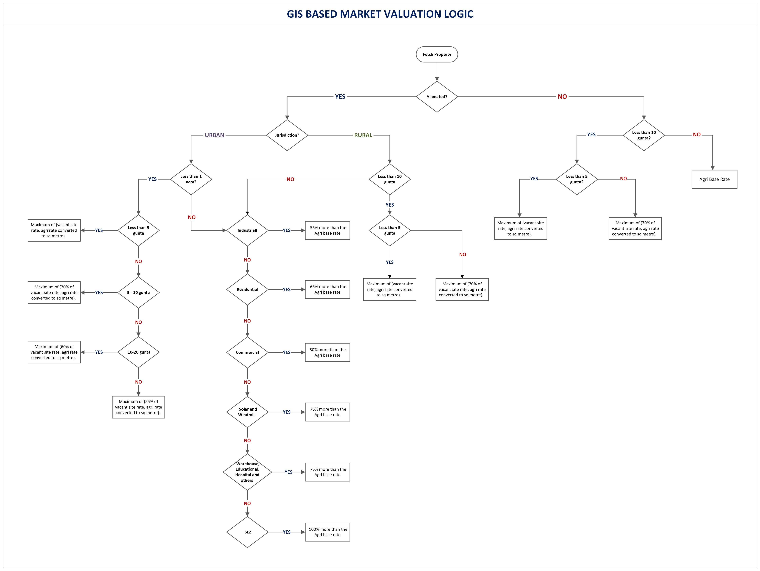

Annexure rules appreciation
The value is appreciated based on the annexure rules.
- Type of land (Khushki, Tari, Bagayat)
- Proximity to Road
- Jurisdictional boundary
- Crop type
- Tree count
- Masterplan zones
- Construction details

The base rates and annexure rules are provided by the Department of Stamps and Revenue. KSRSAC will provide these annexure rule codes via an API to Kaveri to calculate and display the market valuation.

Output documents

The document summary for the citizen must have a description of the basis for arriving at market valuation for each property. It should transparently display the base rate calculation logic and the annexure rules applicable.
The document summary must also have the map of each of the properties transacted.

Scenarios to be considered

- Release phase: Pilot vs non-pilot talukas (including agricultural non-pilot talukas)
- Article type: Articles with and without market valuation
- Property restrictions: Government Land, Government Restrictions including PTCL, Pyki
- Source of property info: Bhoomi and previous document-related
- Extent: Full vs part extent, non-agricultural valuations for less than 10 gunta
- Property use type: Alienated vs agricultural
- Other scenarios: Any combination of properties with the above variations
- User behaviour: Completion in one flow vs pause and resume

Validations
- The value of pre-fetched annexure rules cannot be lowered. Users should not be permitted to decrease the tree count or construction area fetched from KSRSAC; however, they are allowed to increase these values if needed.
- The system should generate the schedule description based on the response fetched from Bhoomi and shouldn’t be allowed to be edited.
- User input fields must not be left blank. If a particular field is not applicable, the user should be instructed to enter 0 as the input value.
- In the case of alienated properties, the system should ask the user to select the land usage type (Residential, Commercial, Industrial, etc.).

Assumptions
- A GIS-based map will not be shown in the following scenarios
  - Restriction on the property (GL/GR/PTCL)
  - Non-piloted talukas
- The overall process flow is consistent for all scenarios – pilot/non-pilot and articles with market valuation and without market valuation.
- GIS-based valuation is dependent on annexure rules provided by KSRSAC.
- The extent of a property will continue to be fetched from Bhoomi.
- The jurisdictional information, i.e. urban/rural for each property will be available from KSRSAC.

Limitations
- Market valuation calculations will be based on the data received from KSRSAC.

Annexures

Annexure – 1: List of modules of Kaveri 2.0

Sl No | Module No | Main Module | Sub-Module
1 | 1.1 | Registration | Registration
2 | 1.2 | Registration | Appointment
3 | 1.3 | Registration | Integration module
4 | 1.4 | Registration | Stamp duty and Registration fee calculation
5 | 1.5 | Registration | Guideline value calculation
6 | 1.6 | Registration | Rule 17 (2) filing
7 | 1.7 | Registration | Rule 17 (3) filing
8 | 1.8 | Registration | Old pending release module
9 | 1.9 | Registration | Re-Registration module
10 | 1.1 | Registration | Will after Death
11 | 1.11 | Registration | Filing documents (FRUITS)
12 | 1.12 | Registration | Scanning
13 | 1.13 | Registration | Memo transmission and filing
14 | 1.14 | Registration | 68(2) correction
15 | 1.15 | Registration | Cross-reference Rule 123
16 | 1.16 | Registration | Integration exemption
17 | 1.17 | Registration | Court entry
18 | 1.18 | Registration | Liability
19 | 1.19 | Registration | Status tracking
20 | 1.2 | Registration | Investigation and Search
21 | 1.21 | Registration | Valuation Module (CVC)
22 | 2 | EC
23 | 3 | CC
24 | 4 | Verify Document
25 | 5 | Power of attorney Authentication Module
26 | 6 | Refund Module
27 | 7.1 | Marriage | Hindu Marriage
28 | 7.2 | Marriage | Special Marriage
29 | 7.3 | Marriage | Special Marriage in Other Forms
30 | 8 | Legacy Record Digitisation
31 | 9 | Audit
32 | 10 | Accounts
33 | 11.1 | MIS | Statutory (44)
34 | 11.2 | MIS | Statistical (54)
35 | 11.3 | MIS | Integration (15)
36 | 11.4 | MIS | Computer related (4)
37 | 11.5 | MIS | Reconciliation (5)
38 | 11.6 | MIS | HR (5)
39 | 12.1 | DRO | Firm Registration
40 | 12.2 | DRO | Undervaluation
41 | 12.3 | DRO | Deposit of will
42 | 12.4 | DRO | Adjudication of documents
43 | 13 | IGRO | Appeal
44 | 14 | Master Data Management
45 | 15 | User Management
46 | 16 | Mobile application
47 | 17 | Training Module | Master Trainer, Training Plan

Annexure- 2: Requirements as shared by the department

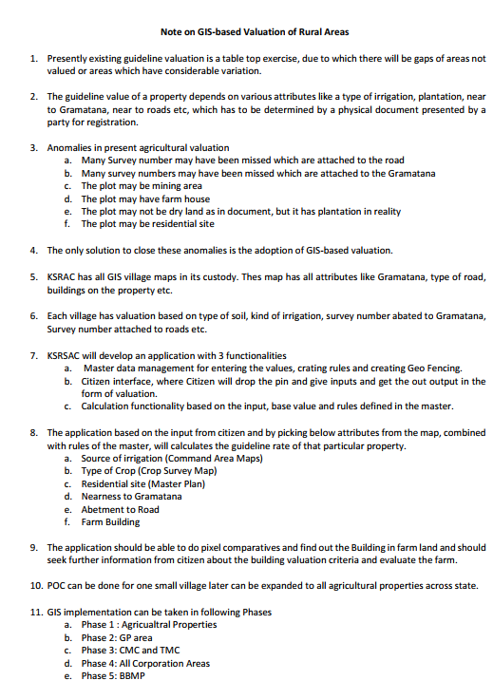

Annexure – 3: Agrilandtypes masters

Agrilandtype | Description
1 | Dry, No Source of Irrigation, Black Soil
2 | Dry, No Source of Irrigation,Red Soil
3 | Dry, No Source of Irrigation,Other
4 | Dry, Paddy/Areca/Coconut/Mango/Grapes/Fruit grown with rain water, Black Soil
5 | Dry, Paddy/Areca/Coconut/Mango/Grapes/Fruit grown with rain water, Red Soil
6 | Dry, Paddy/Areca/Coconut/Mango/Grapes/Fruit grown with rain water, Other Soil
7 | Dry, Irrigation by pumping water from river/ canal/ stream/ pond, Black Soil
8 | Dry, Irrigation by pumping water from river/ canal/ stream/ pond, Red Soil
9 | Dry, Irrigation by pumping water from river/ canal/ stream/ pond, Other Soil
10 | Bagayat, Dry
11 | Bagayat, Wet
12 | Wet (Assured Water Supply from Government Tanks/Canals), Two Crops of Paddy
13 | Wet (Assured Water Supply from Government Tanks/Canals), Sugarcane
14 | Wet (Assured Water Supply from Government Tanks/Canals), One Crop
15 | Wet (Assured Water Supply from Government Tanks/Canals), Lift Irrigation
16 | Wet (Assured Water Supply from Government Tanks/Canals), Garden/Areca/Coconut
17 | Plantation, Coffee/Pepper
18 | Plantation, Cardamom/Pepper
19 | Plantation, Rubber/Areca nut
20 | Plantation, Tea
23 | Dry Agriculture Land, Irrigated By Bore / Well / Pumpset, Other Soil
24 | Dry, No Source of Irrigation, Loamy Soil
26 | Dry, Paddy/Areca/Coconut/Mango/Grapes/Fruit grown with rain water ,loamy Soil
27 | Dry, Irrigation by pumping water from river/ canal/ stream/ pond, loamy Soil
28 | Dry,Areca,coconut,Rubber,CashewNut
29 | Plantation Coffee(Low Grade)
30 | Plantation Coffee(High Grade)
31 | Bagayat Coconut(Plant Within 2 years)
32 | Bagayat Coconut
33 | Bagayat Arecanut & venilla(Plant Within 2 years)
34 | Bagayat Arecanut & venilla
35 | Plantation, Cardamom/Pepper(Low Grade)
36 | Plantation, Cardamom/Pepper(High Grade)
37 | Plantation, Coffee/Cardamom
38 | Plantation, Coffee/Cardamom/Pepper
39 | Dry, No Source of Irrigation,Maradi
40 | Dry, No Source of Irrigation, Garasu
41 | Non-Agriculture Land
42 | Dry Agriculture Land, Irrigated By Bore / Well / Pumpset, Black Soil
43 | Dry Agriculture Land, Irrigated By Bore / Well / Pumpset, Red Soil
44 | NA Dry land (Undeveloped) - Residential Use
45 | NA Dry land (Undeveloped) - Commercial Use
46 | NA Dry land (Undeveloped) - Industrial Use
50 | NA Wet land (Undeveloped) - Residential Use
52 | NA Wet land (Undeveloped) - Industrial Use
53 | NA Bhagayat land (Undeveloped) - Residential Use
55 | NA Bhagayat land (Undeveloped) - Industrial Use
57 | Wet Pond
58 | Coconut Tree in Dry Land
59 | Coconut Tree in Wet Land
60 | Arecanut Tree in Dry Land
61 | Arecanut Tree in Wet Land
63 | Bagayath - Maradi
64 | Bagayath - Masari
65 | Bagayath - yari

Changes suggested during the demo

Sl. No | Changes suggested by the department during the demo
1 | Survey numbers and the Proceed button should be visible prominently on the Map provided by KSRSAC.
2 | The area should be shown as Acres, Gunta and Cents.
3 | User input must not be left blank. Currently, users manually enter construction details and the number of trees if KSRSAC does not provide this information. A validation should be implemented to ensure that users input these details before proceeding further.
4 | A disclaimer should be shown in the UI for the Construction and Tree count declared by the citizen.
5 | The disclaimer message will be provided by the department.
6 | The SR should be able to change the citizen input values such as Land type, Construction details and Number of trees during the market valuation and based on SR input the market valuation should be updated.
7 | Valuation details (including annexures) of all the properties with a Map should be shown in the SR summary in the valuation sections.
8 | On the property schedule page,  - the checkbandi details are currently editable; instead, these details should be retrieved from the Bhoomi/Mojani response.  - The property description should be auto-generated based on the fetched property details, and the application should restrict the user from manually entering the information.
9 | In the case of alienated properties, the system should ask the user to select the land usage type ( Residential, Commercial, Industrial, etc.).
10 | The department will share the revised rates for alienated properties and the base rates will remain the same for less than 5 gunta properties as that of non-agri properties.

Annexure 5: Annexure Rules for Market valuation of Agricultural Properties
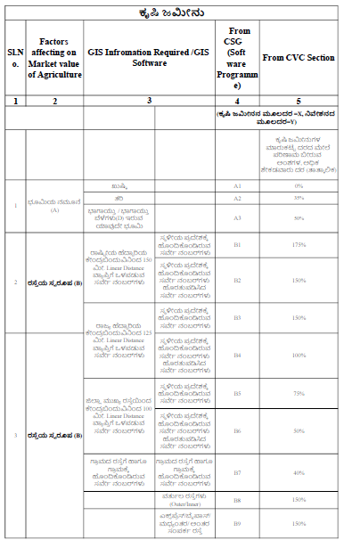

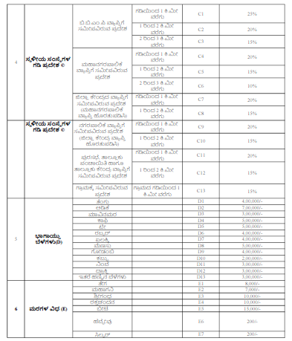

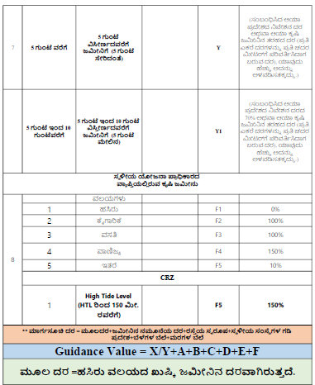

Annexure 6: Annexure Rules for Market valuation of Non -Agricultural properties

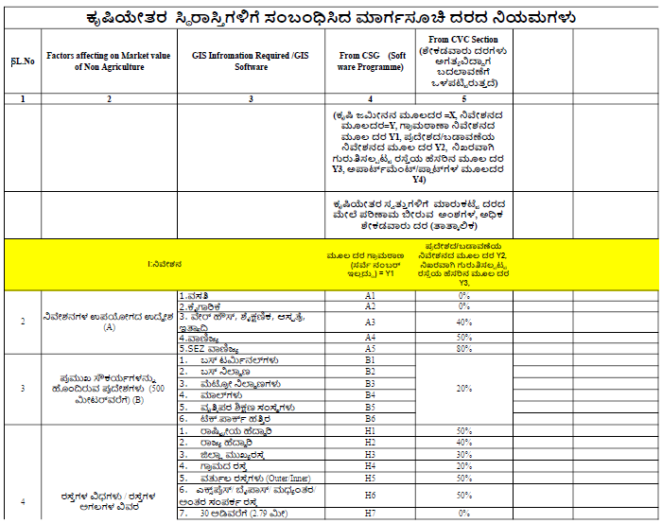
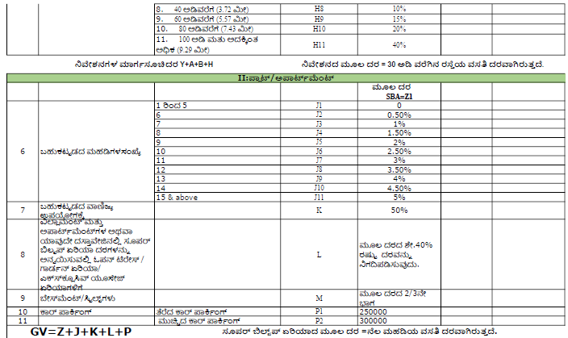

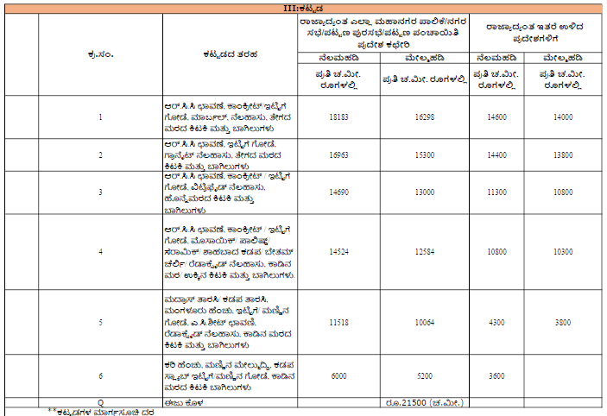

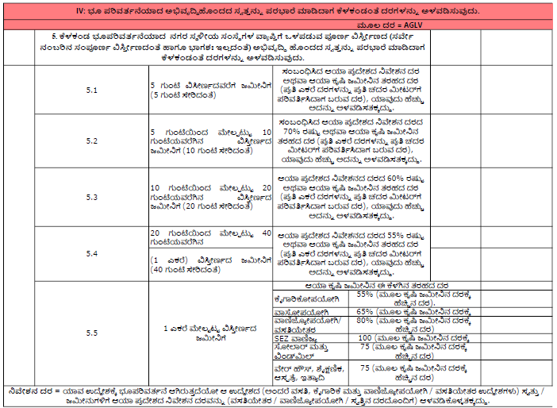
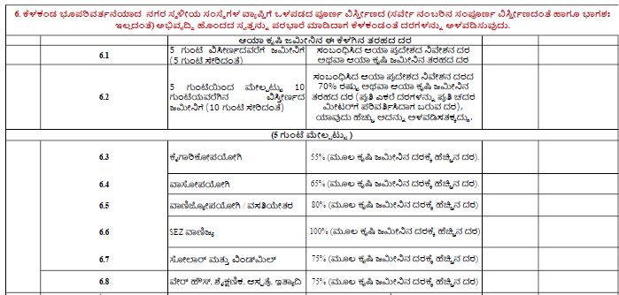

To maintain the flow of GIS Market valuation, market valuation for all the properties will be done after fetching the properties in the property search page to maintain the common flow in all the districts and talukas.

